**F. Y. B. Tech Academic Year 2021-22**

**Subject:** Programming and Problem Solving **Trimester:** 2

**Name:** Shreerang Mhatre  **Division:** 11

**Roll No:** 111056  **Batch:** K3

**ASSIGNMENT NO: 4**

**AIM**: Write a menu driven program to perform basic operations such as

addition and subtraction of two matrices.

**OBJECTIVE:**

1.To learn and understand arrays in C.

2.To learn and understand two dimensional arrays and operation on it.

**THEORY:**

An array is a data structure that allows to store multiple values. ... Each element

of an array is accessed by their index (arr[index] = value). The access time to an element

by index is constant, regardless of the desired element. This is explained by the fact that

the array elements are contiguous in memory.

Matrix is a two-dimensional array. And to represent the two-dimensional array there

should be two loops, where outer loops represent rows of the matrix and the inner loop represents the column of the matrix. Now, let us start with the addition of two matrices.

**Platform: 64 –**bit Windows 10**.**

**Technology:** Open Source Visual Studio Code

**Algorithm:**

**Step1) START**

**Step2) Input the order of matrix**

**(Enter the number of rows and columns of the matrix)**

**Step3) Enter the elements of first matrix**

**Step4) Enter the elements of second matrix**

**Step5) Display the first matrix**

**Step6) Display the second matrix**

**Step7) Calculate the sum of two entered matrices using formula**

**Sum[c][d] = First[c][d] + Second[c][d]**

**Step8) Display the Addition of two entered matrices**

**Step9) Calculate the diff of two entered matrices using formula**

**Diff[c][d] = First[c][d] – Second[c][d]**

**Step10) Display the Substraction ot two entered matrices**

**Step11) STOP**

**Flowchart:**

START

Input order (m ,n)

First matrix [c][d]

Second matrix [c][d]

Display First matrix

Display Second matrix

Basic

ops

Matrix

subtraction

Matrix

Addition

Sum[c][d] = First[c][d] +

Second[c][d]

Diff[c][d] = First[c][d] -

Second[c][d]

Display Sum of

two matrices

Display Diff of

two matrices

ops

completed

STOP

**Visual Studio Code :**

**Code for given program:**

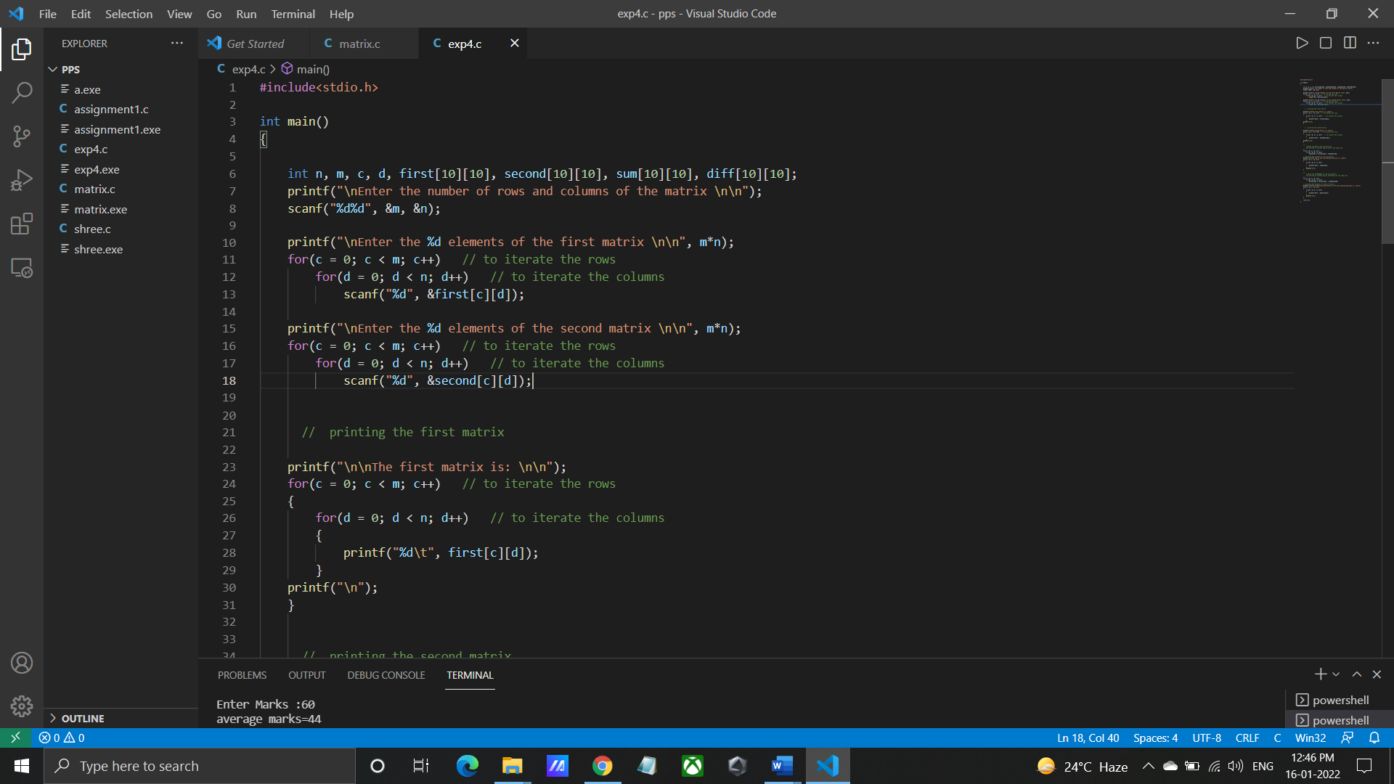

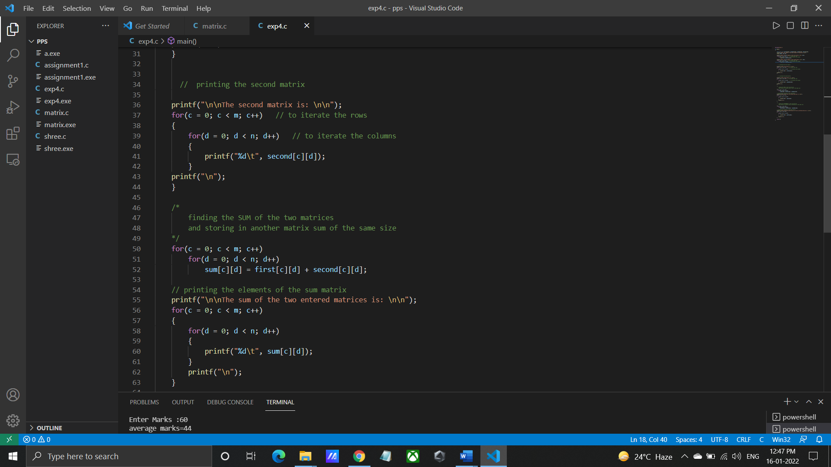

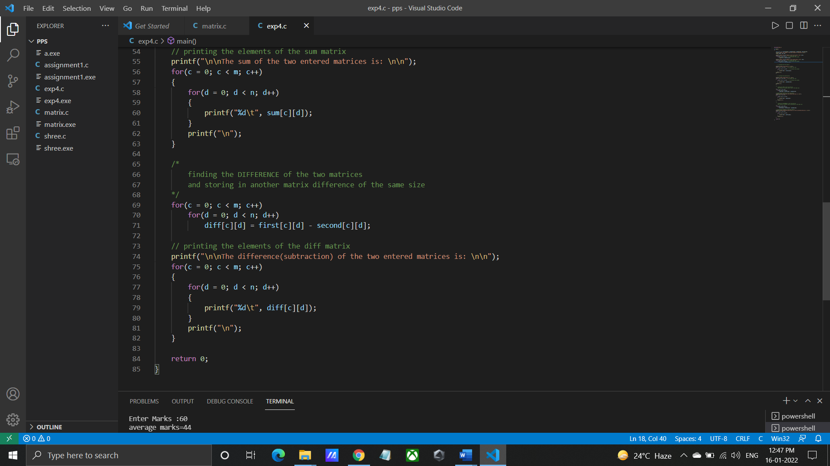

**Output for given program:**

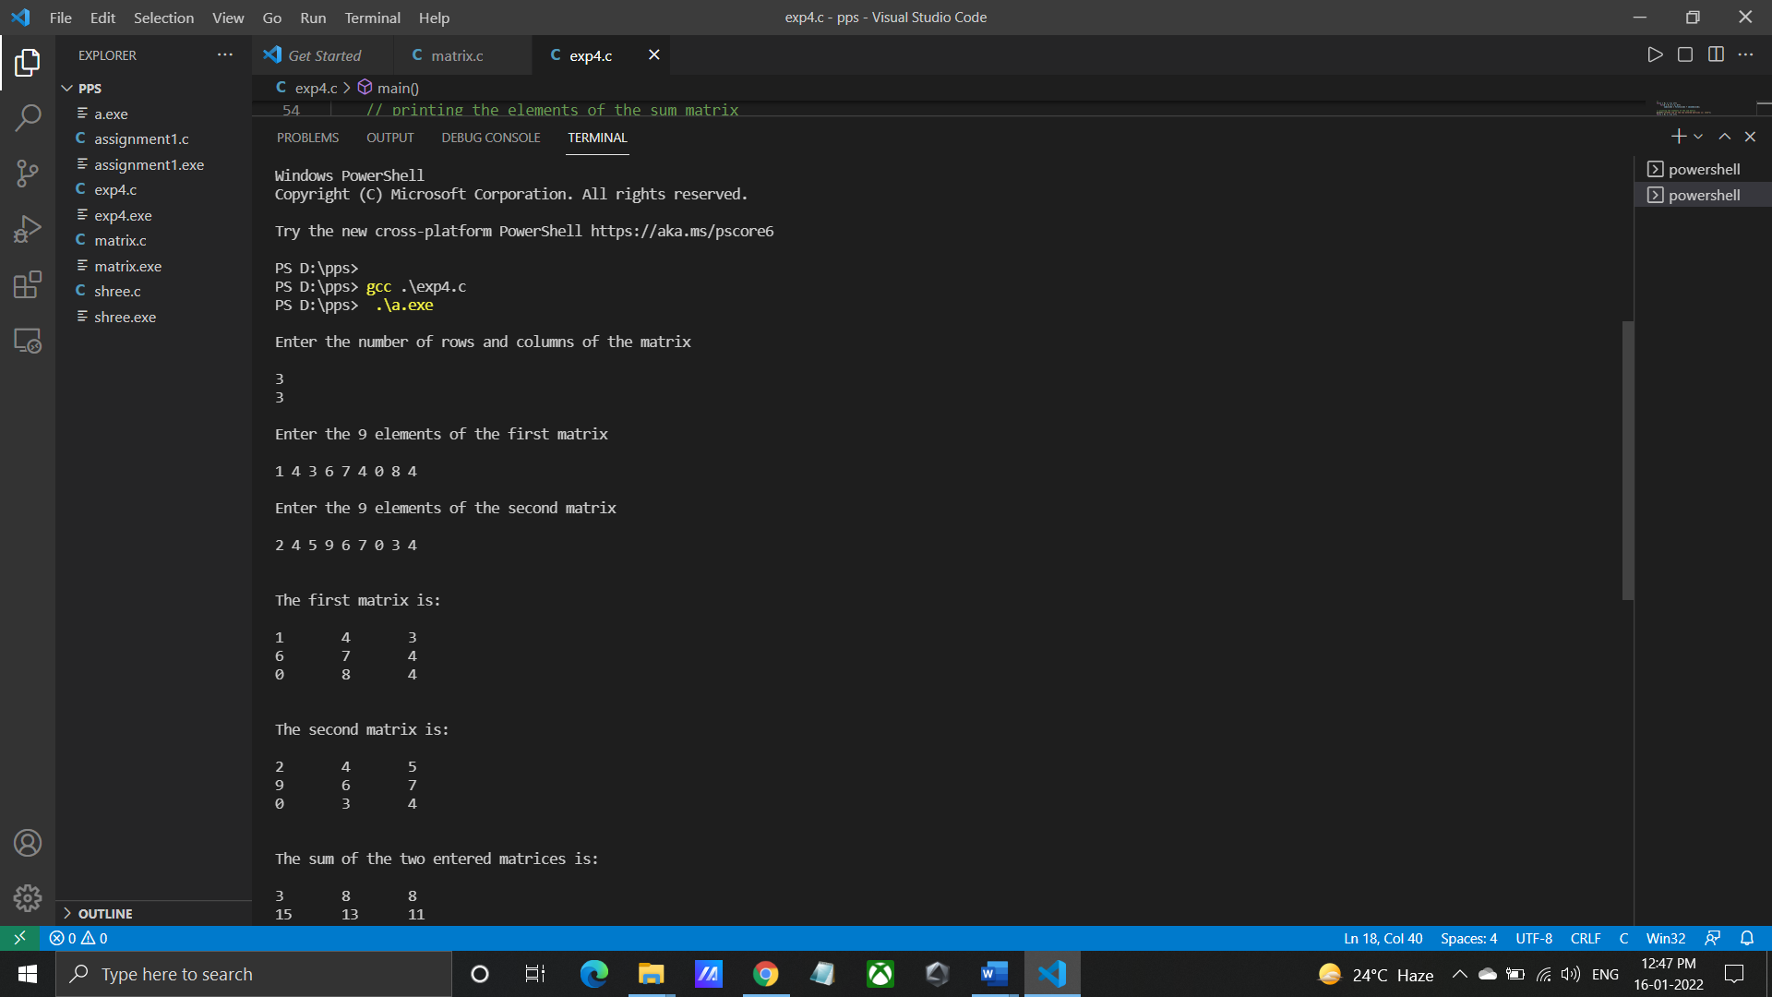

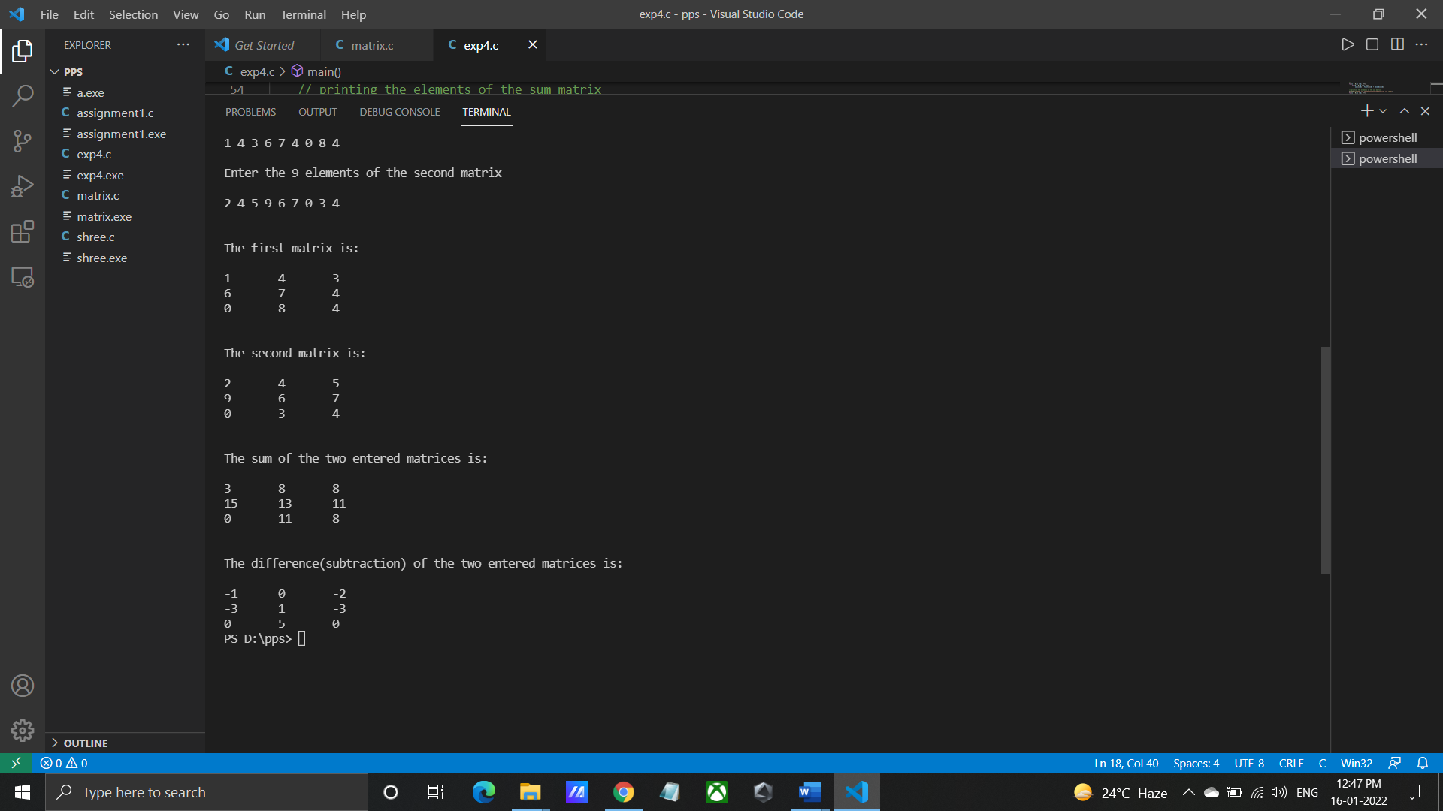

**INPUT:** Enter first matrix elements: 1 4 3 6 7 4 0 8 4

Enter second matrix elements: 2 4 5 9 6 7 0 3 4

**OUTPUT:** Addition of two matrices is:

3 8 8

15 13 11

0 11 8

Substraction of two matrices is:

-1 0 -2

-3 1 -3

0 5 0

**CONCLUSION:** Thus implemented the program to perform addition and

subtraction of two matrices.

**FAQ:**

**1.**What are different types of arrays? How do we define them?

ANS: Array: collection of fixed number of components (elements), wherein all of

components have same data type.

One-dimensional array: array in which components are arranged in list form.

Multi-dimensional array: array in which components are arranged in tabular form.

**2.** How are arrays initialized and processed?

ANS: Arrays may be initialized when they are declared, just as any other variables.The

remaining array elements will be automatically initialized to zero. If an array is to be

completely initialized, the dimension of the array is not required. The compiler will

automatically size the array to fit the initialized data.

**3.** How are the elements accessed in 2D arrays?

ANS: An element in 2-dimensional array is accessed by using the subscripts. That is, row

index and column index of the array.